> restart:
> with(plots);
Warning, the name changecoords has been redefined

vvod ishodnyh dannyh
F(u)=cosu, U0(x)=x,

> F:=u->cos(u);
> U0:=x->x-1;
>
rewenie uravneniya u-U0(x-F(u)*t)=0 pri t=0

> implicitplot(u-U0(x)=0,x=-1..1,u=-1..1);

> A1:=implicitplot((u-U0(x-diff(cos(u),u)*0.1)=0,x=-1..2,u=-1..1),style=line,color=red):
> A2:=implicitplot((u-U0(x-diff(cos(u),u)*0.2)=0,x=-1..2,u=-1..1),style=line,color=blue):
> A3:=implicitplot((u-U0(x-diff(cos(u),u)*0.3)=0,x=-1..2,u=-1..1),style=line,color=yellow):
> A4:=implicitplot((u-U0(x-diff(cos(u),u)*0.4)=0,x=-1..2,u=-1..1),style=line,color=green):
> A5:=implicitplot((u-U0(x-diff(cos(u),u)*0.5)=0,x=-1..2,u=-1..1),style=line,color=orange):
> A6:=implicitplot((u-U0(x-diff(cos(u),u)*0.6)=0,x=-1..2,u=-1..1),style=line,color=black):
> A7:=implicitplot((u-U0(x-diff(cos(u),u)*0.7)=0,x=-1..2,u=-1..1),style=line,color=red):
> A8:=implicitplot((u-U0(x-diff(cos(u),u)*0.8)=0,x=-1..2,u=-1..1),style=line,color=blue):
> A9:=implicitplot((u-U0(x-diff(cos(u),u)*0.9)=0,x=-1..2,u=-1..1),style=line,color=green):
> A10:=implicitplot((u-U0(x-diff(cos(u),u)*1)=0,x=-1..2,u=-1..1),style=line,color=orange):
> A11:=implicitplot((u-U0(x-diff(cos(u),u)*1.1)=0,x=-1..2,u=-1..1),style=line,color=black):
>
> display({A1,A2,A3,A4,A5,A6,A7,A8,A9,A10,A11});
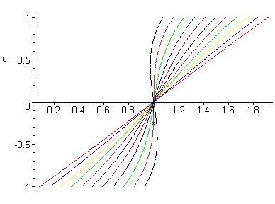
>
> Максимальное время равно 1

